**Task 1.A**

**Terminal:**

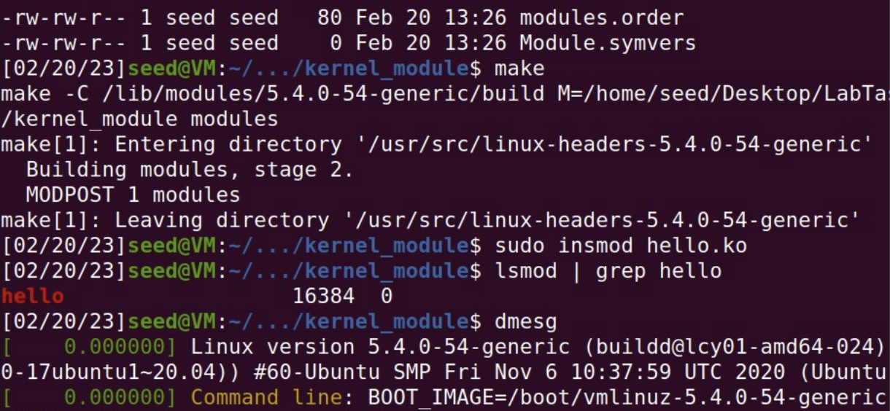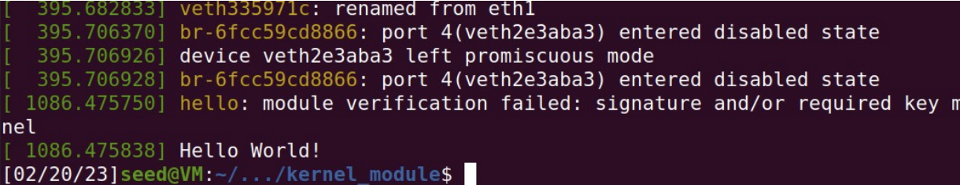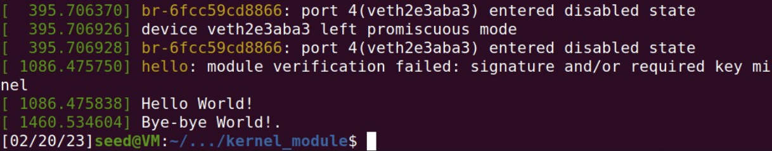

**Description:**We just compile and execute the c code to create simple firewall.

**Task 1.B.1**

**Terminal:**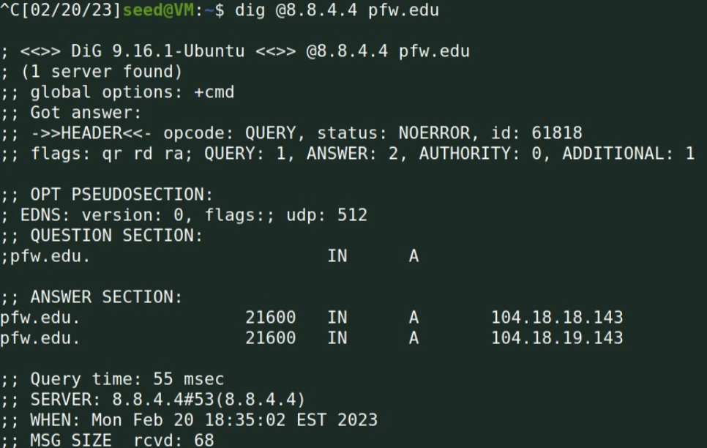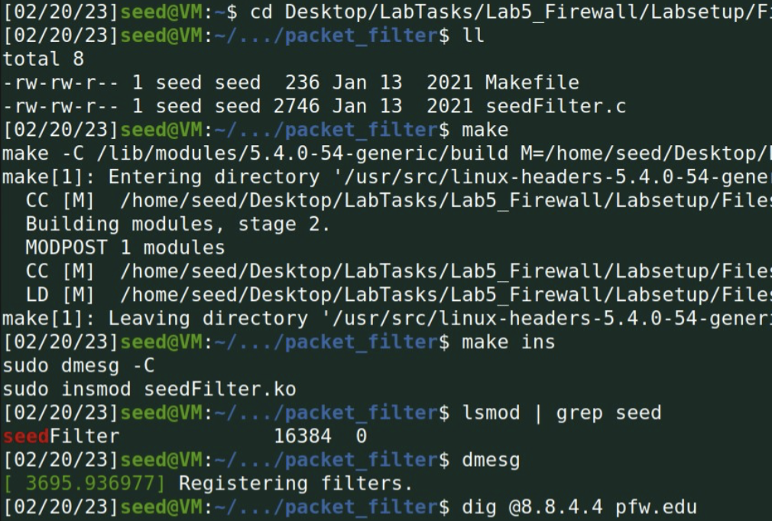

**Code:**

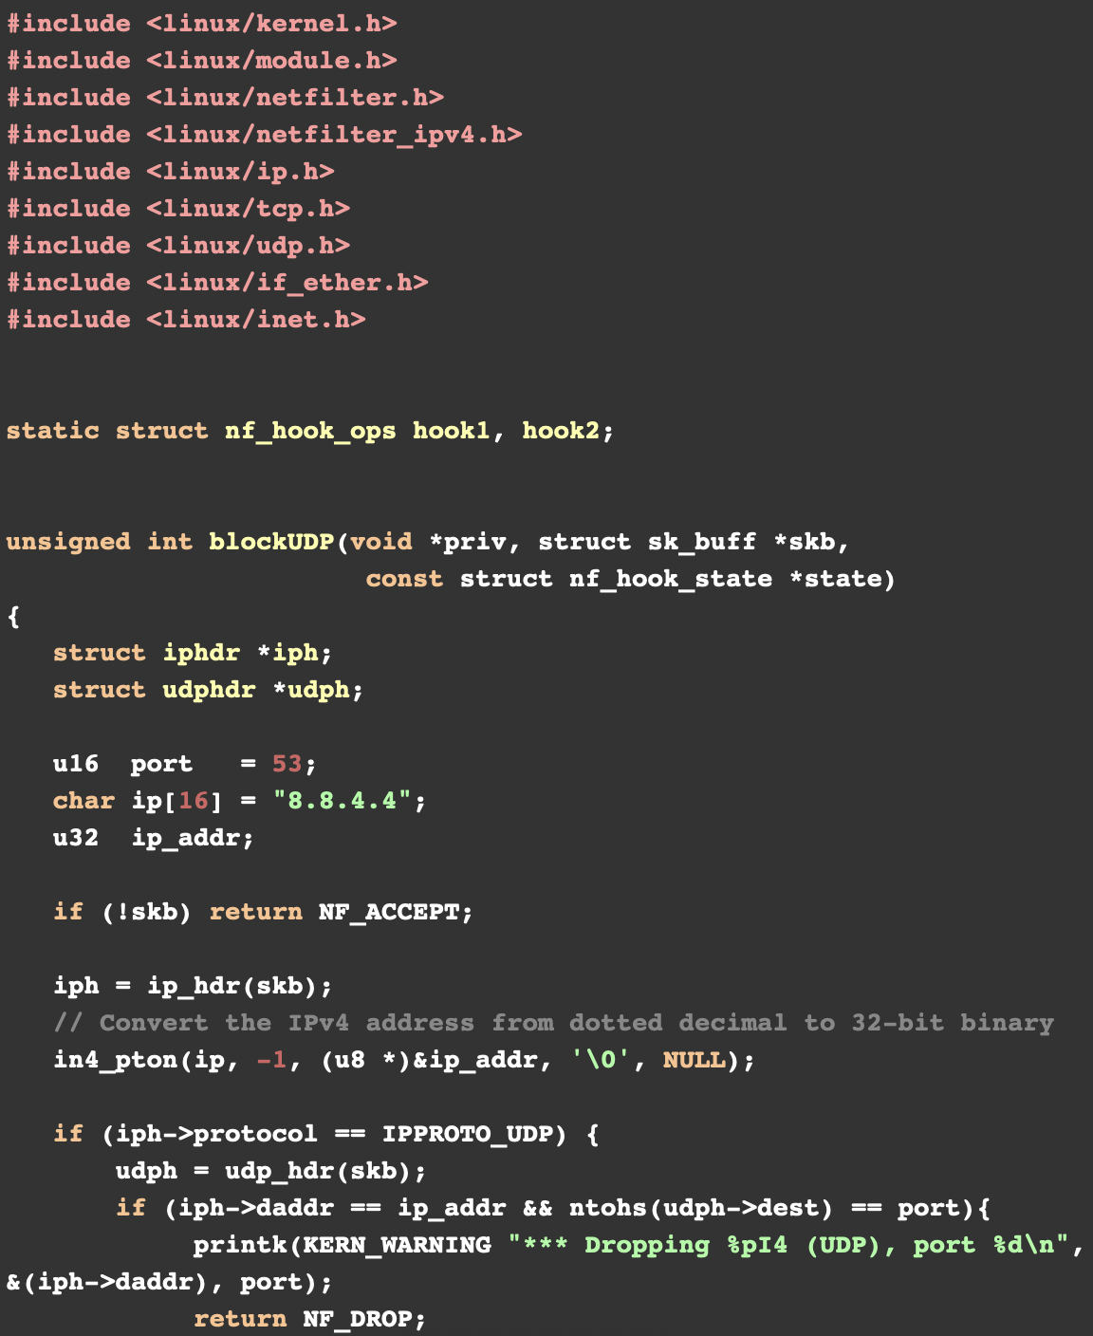

**Description:**Firewall is working as expected

**Task 1.B.2**

**Code:**

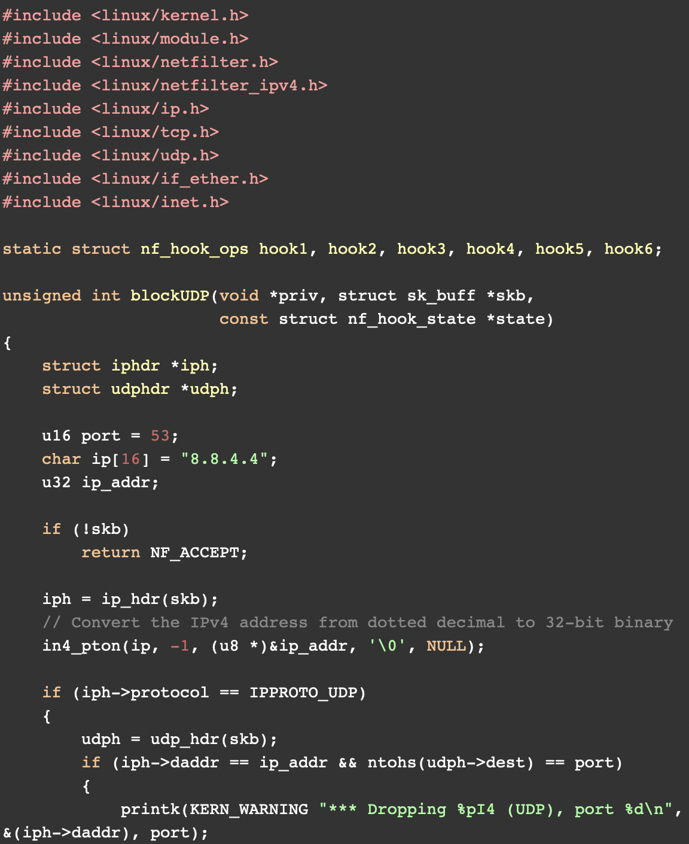

**Terminal:  
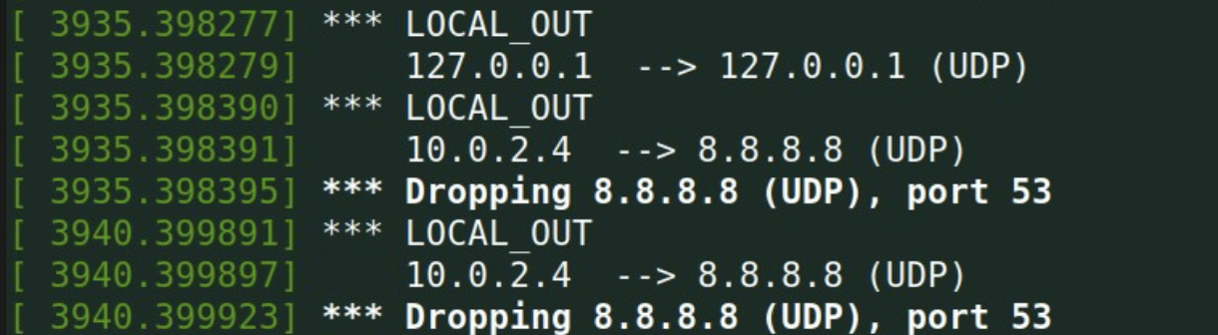**

**Description:**We successfully check info of all hocks.

**Task 1.B.3**

**Code:**

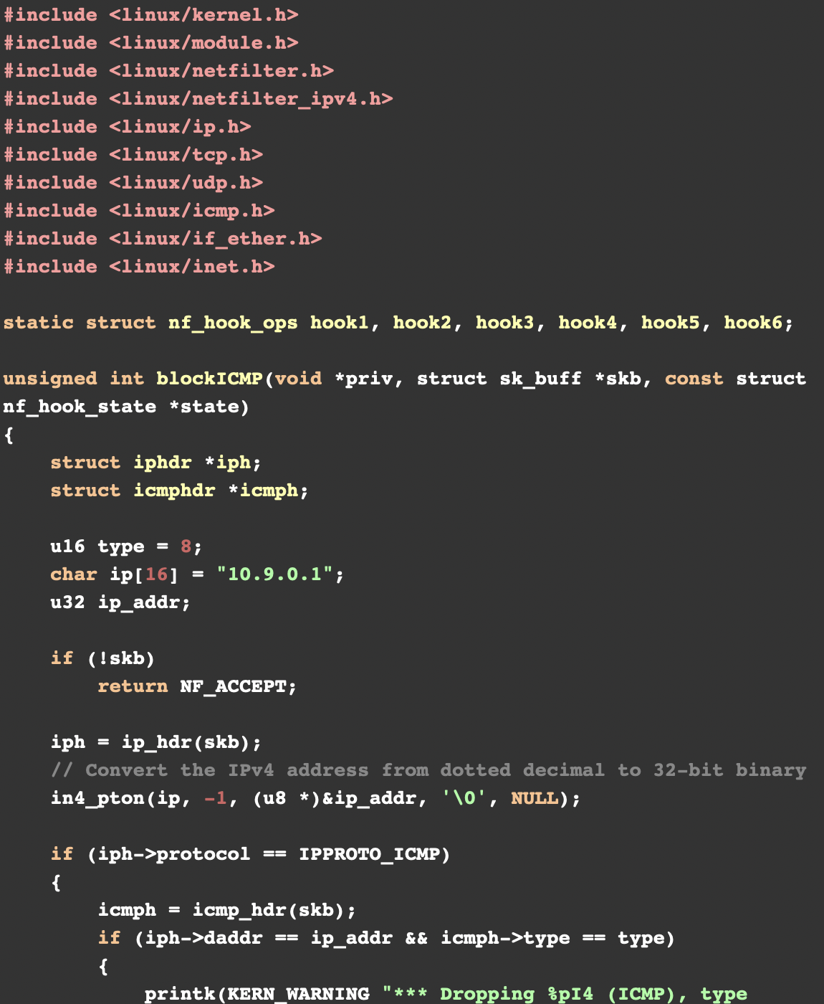

**Terminal:  
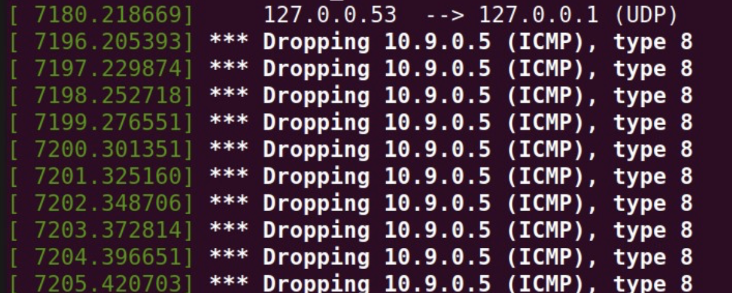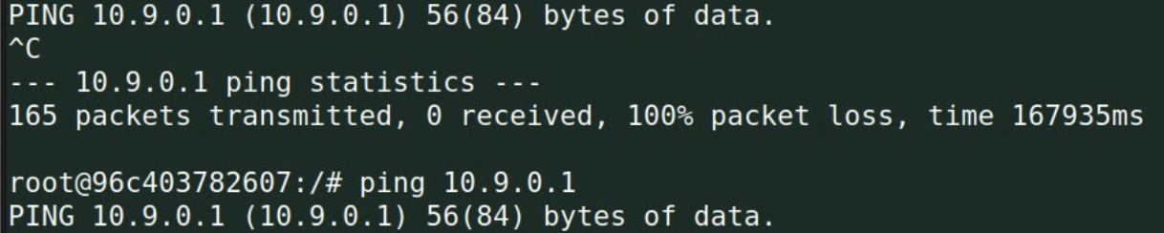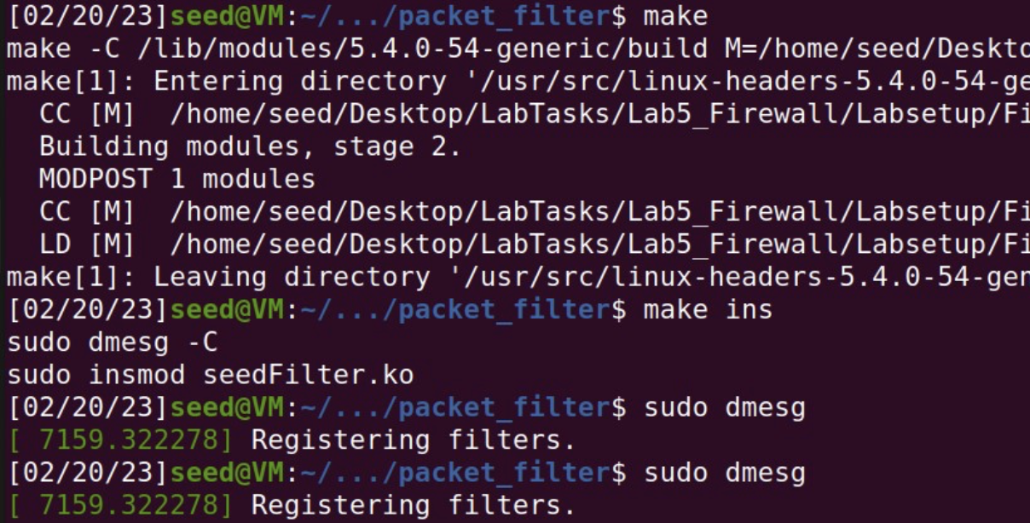**

**Description:**I Implemented two more hooks to achieve preventing other computers to ping and telnet into the VM.

**Task 2.A**

**Terminal:  
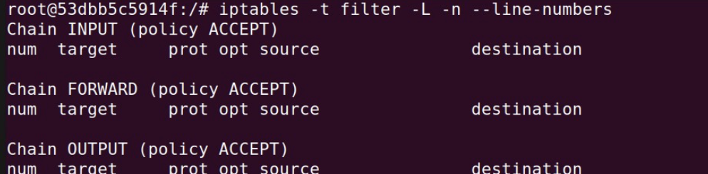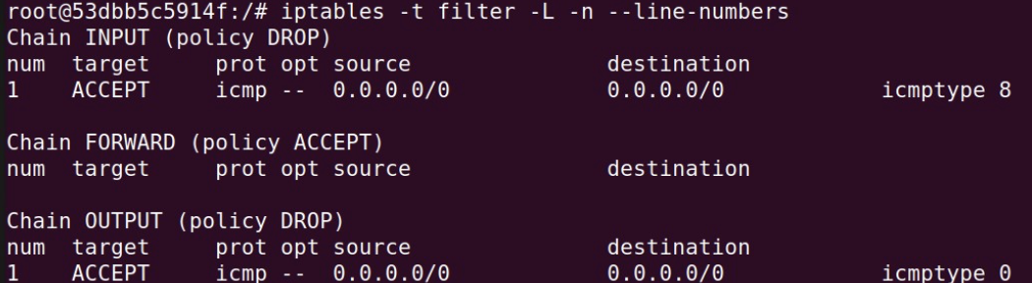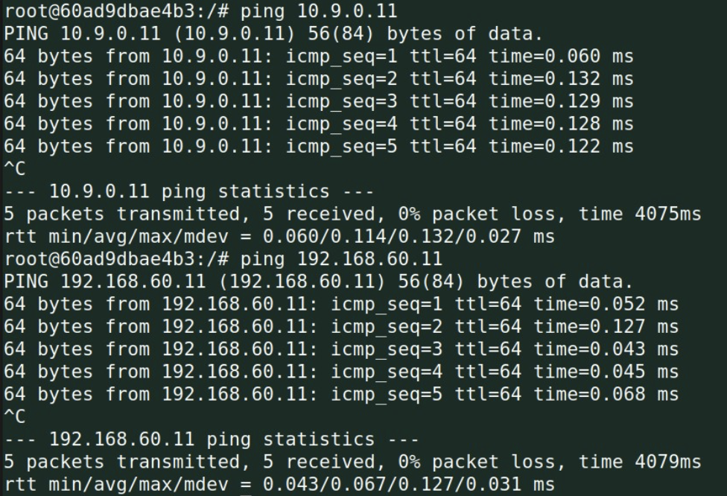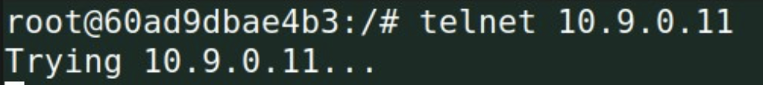**

**Description:**I was able to prevent anything to go through except ping like we can see telnet didnot go through.

**Task 2.B**

**Terminal:  
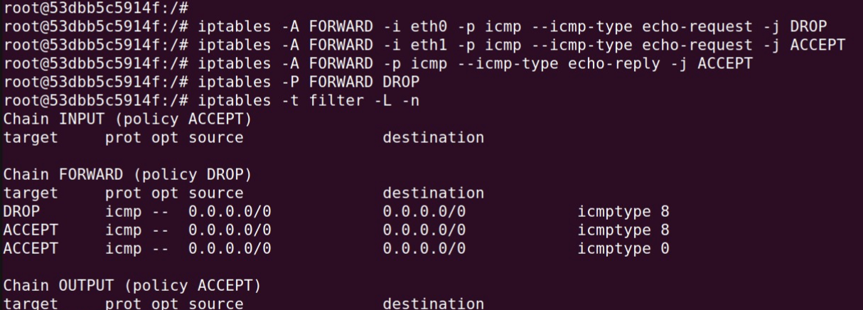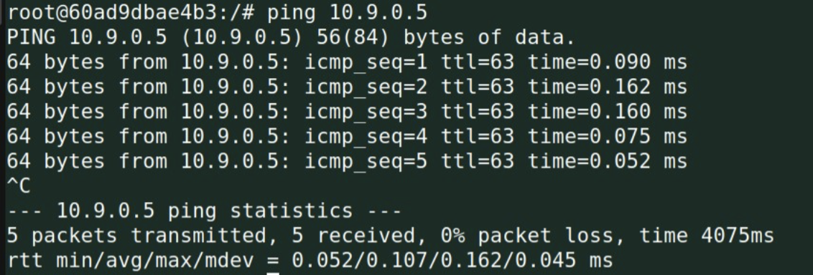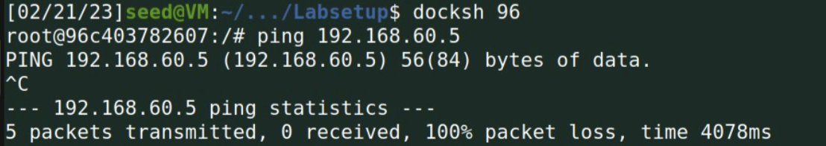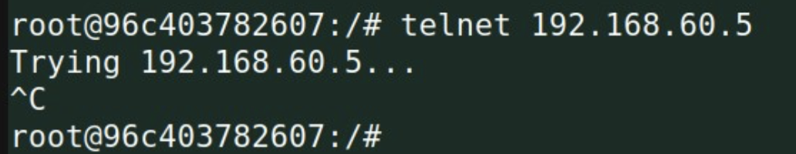**

Description:  
I was able to implement a firewall to protect the internal network 192.168.60.0/24. More specifically, to enforce the restrictions on the ICMP traffic using all the four rules stated in the documentation.

**Task 2.C**

**Terminal:**

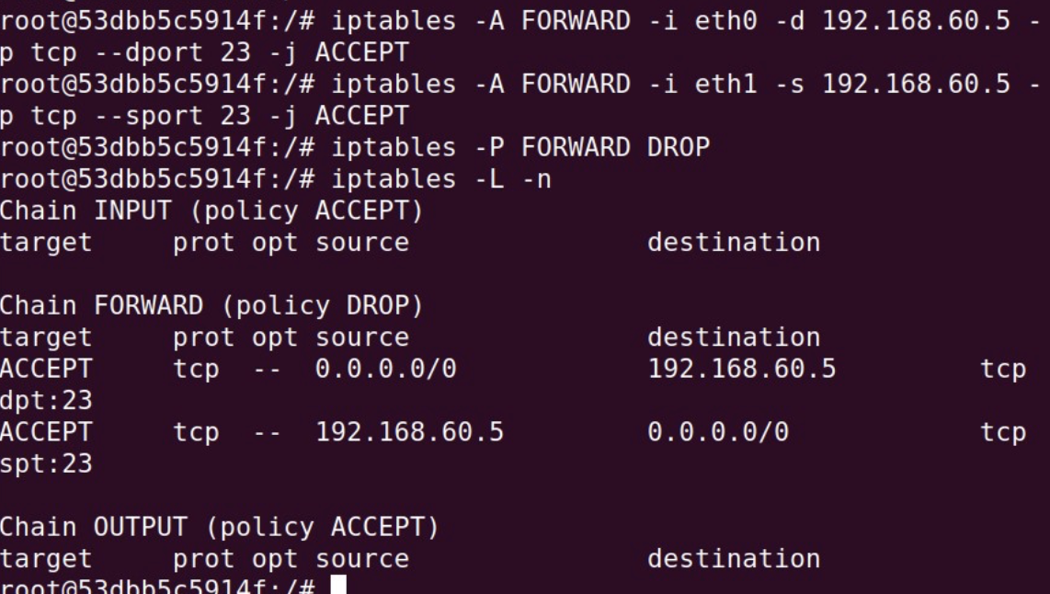

**Outside hosts:**

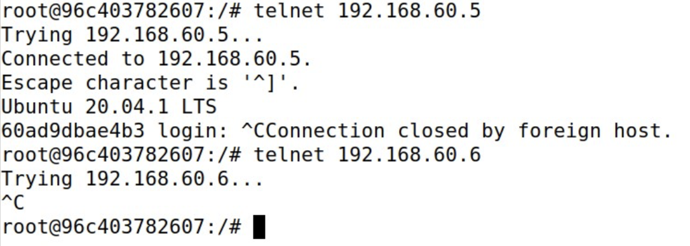**Internal hosts:**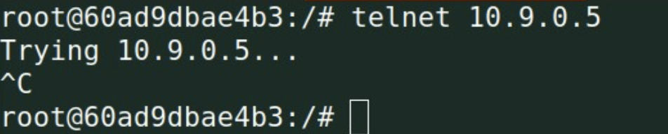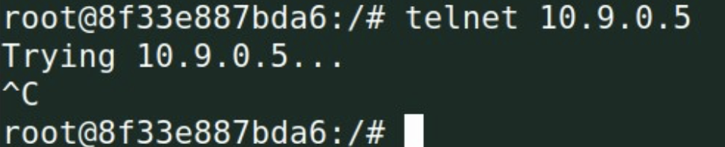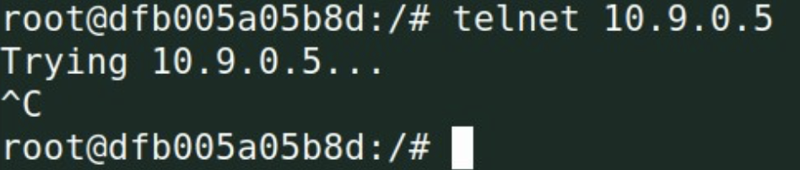

**Descriptions:**I was able to protect the TCP servers inside the internal network (192.168.60.0/24). This includes the

router, outside host and the internal servers.

1. All the internal hosts run a telnet server (listening to port23). Outside hosts can only access the telnet

server on192.168.60.5, not the other internal hosts.

2. Outside hosts cannot access other internal servers.

3. Internal hosts can access all the internal servers.

4. Internal hosts cannot access external servers.

**Task 3.A**

**Terminal:  
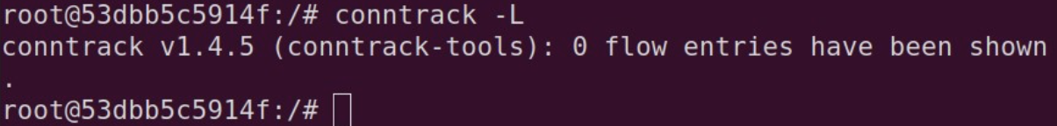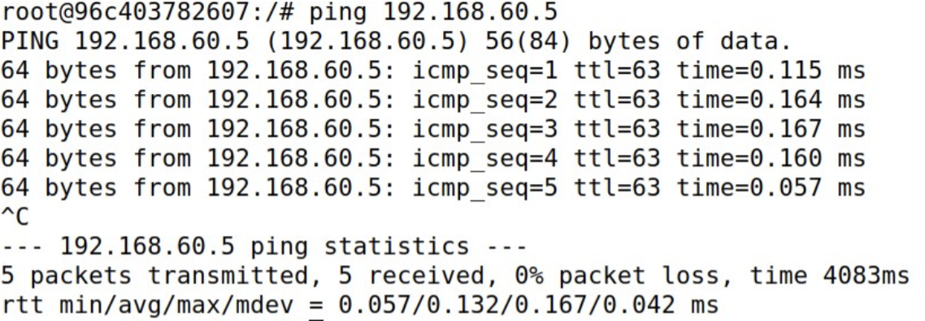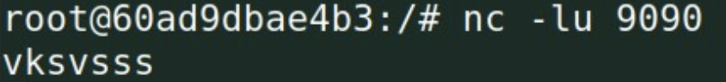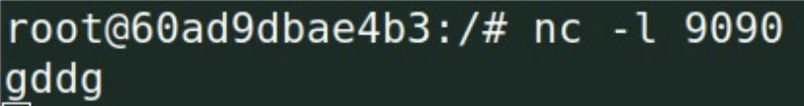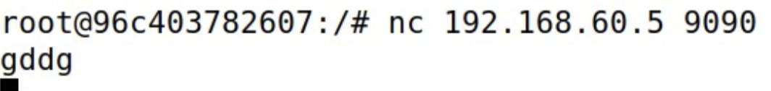**

**Description:**I checked the connection tracking information on the router container. Then, I tried ICMP, UDP and TCP experiment.

**Task 3.B**

**Terminal:  
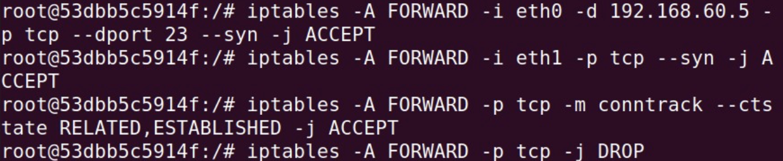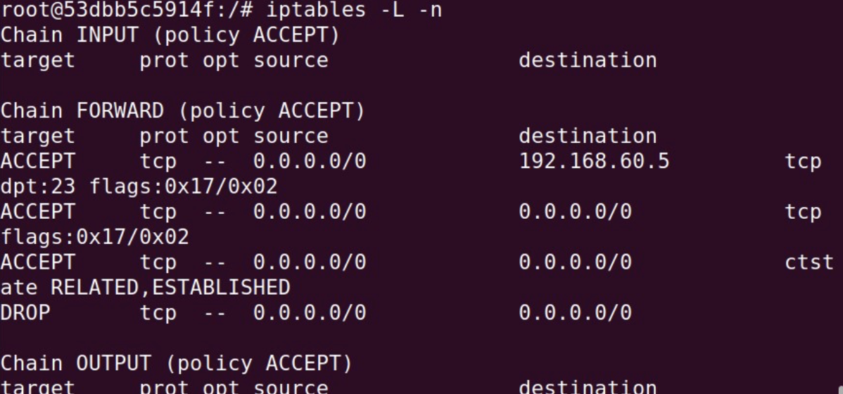External Host: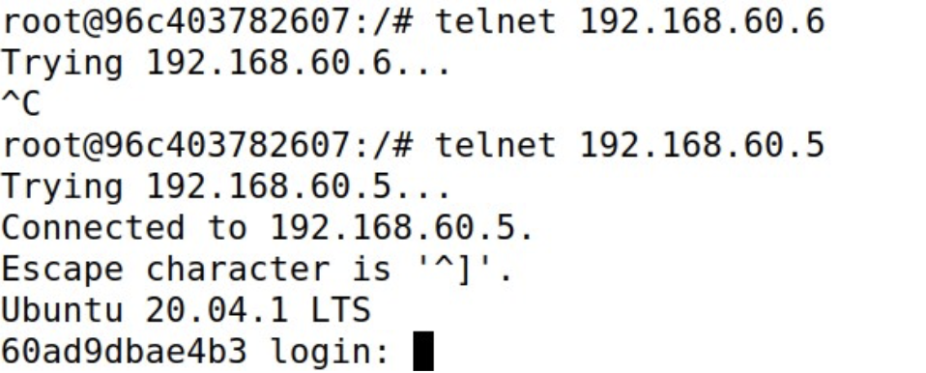Internal Host:**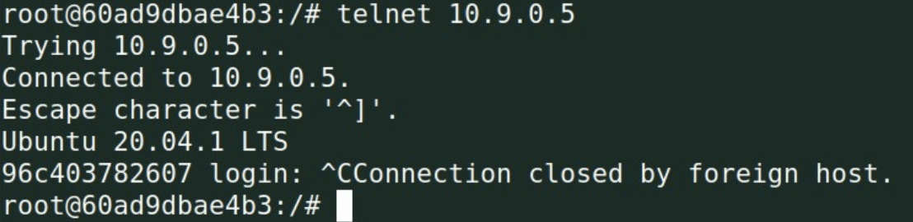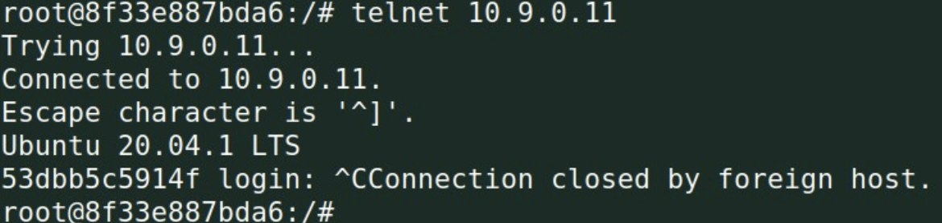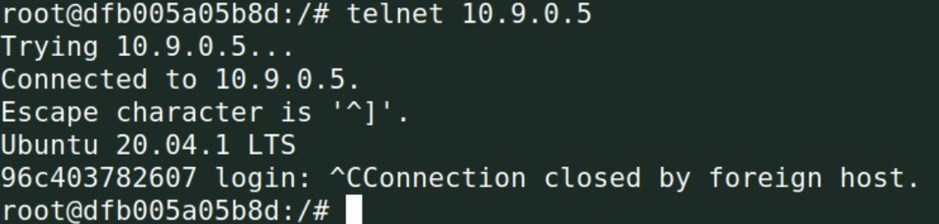

**Description:**I set up firewall rules based on connections. The rule allows TCP packets belonging to an existing connection to pass through as you can see above.

**Task 4**

**Terminal:**

I used it to load balance three UDP servers running in the internal network. Starting the server on each of the hosts:192.168.60.6, and 192.168.60.7. 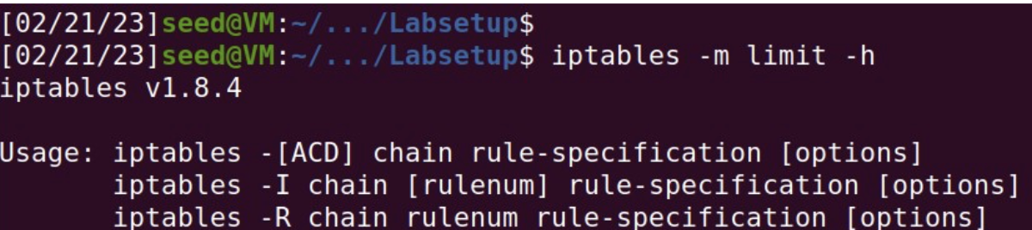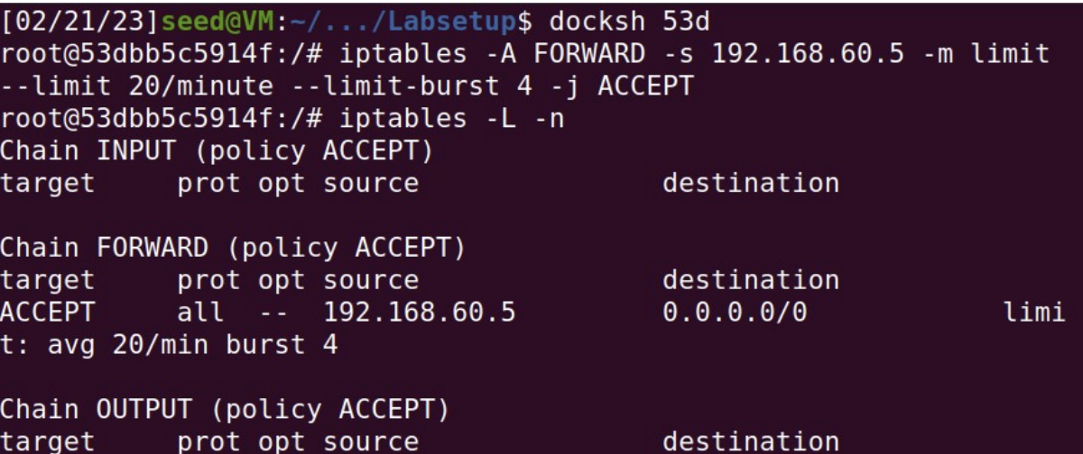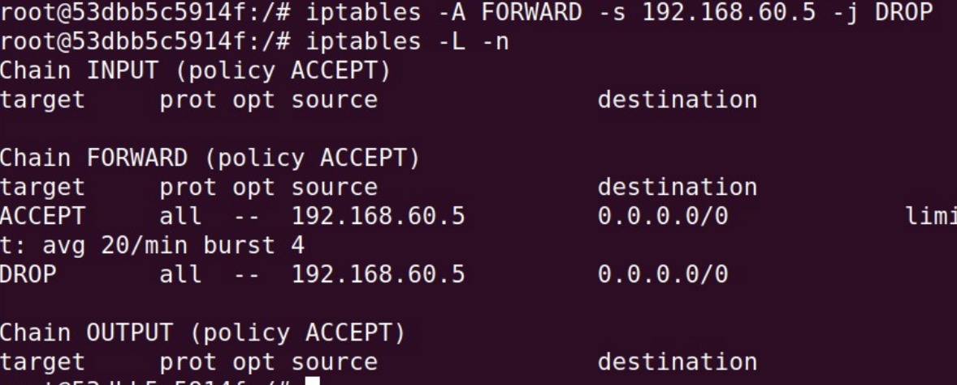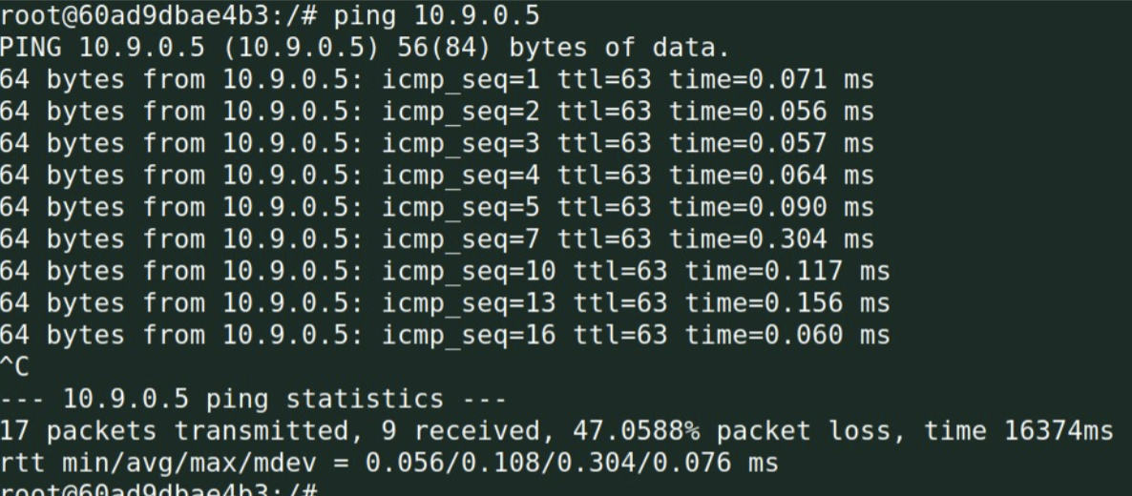

**Description:**I used this module to limit how many packets from10.9.0.5 are allowed to get into the internal network to accept each packet message every three (3) minutes, then 1 packet results drop after 3 sec each.

**Task 5**

**Terminal:  
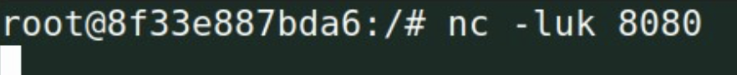**

**Using the nth mode (round-robin)**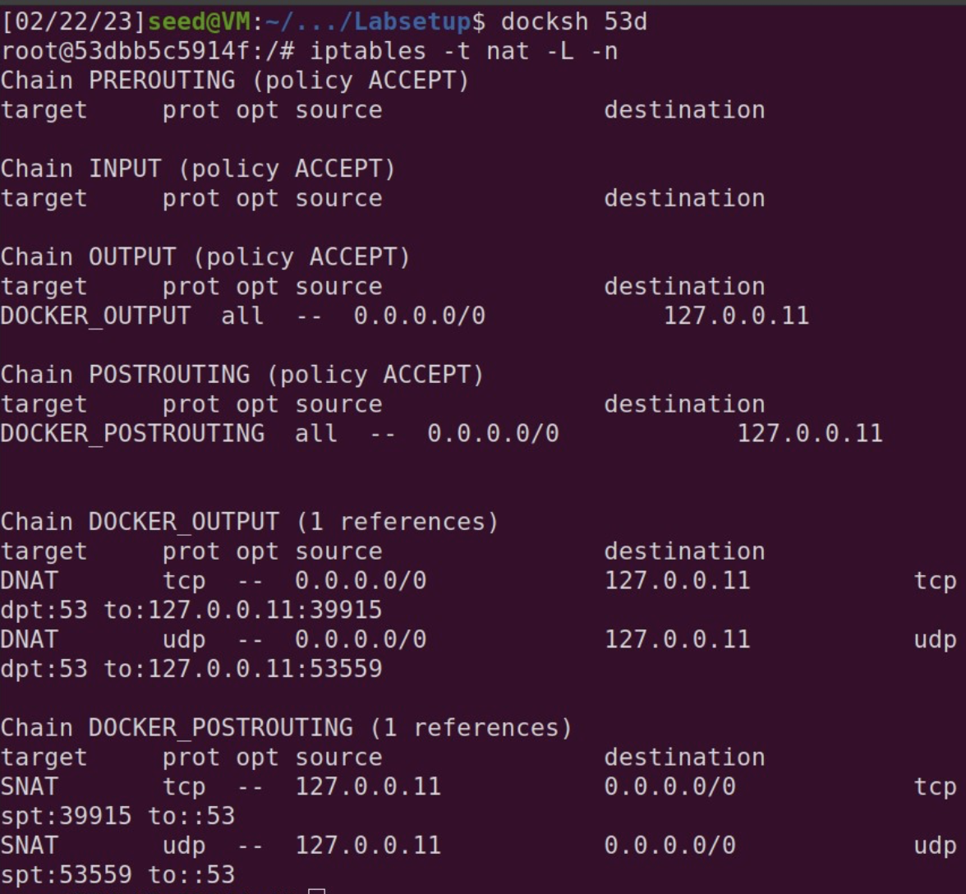

**This for UDP server 192.168.60.6**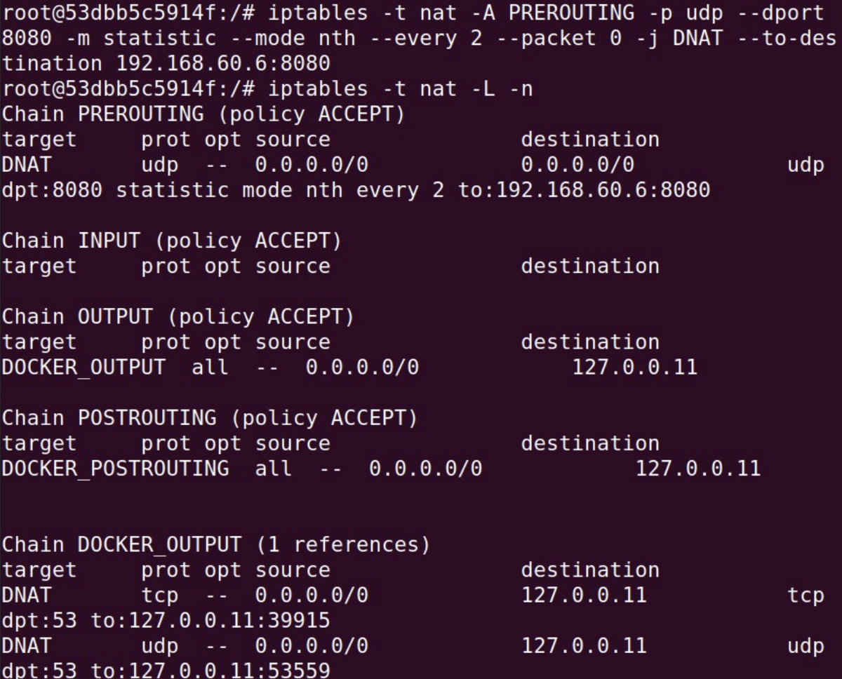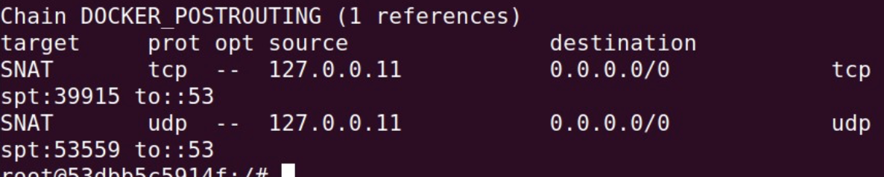

**This for UDP server 192.168.60.7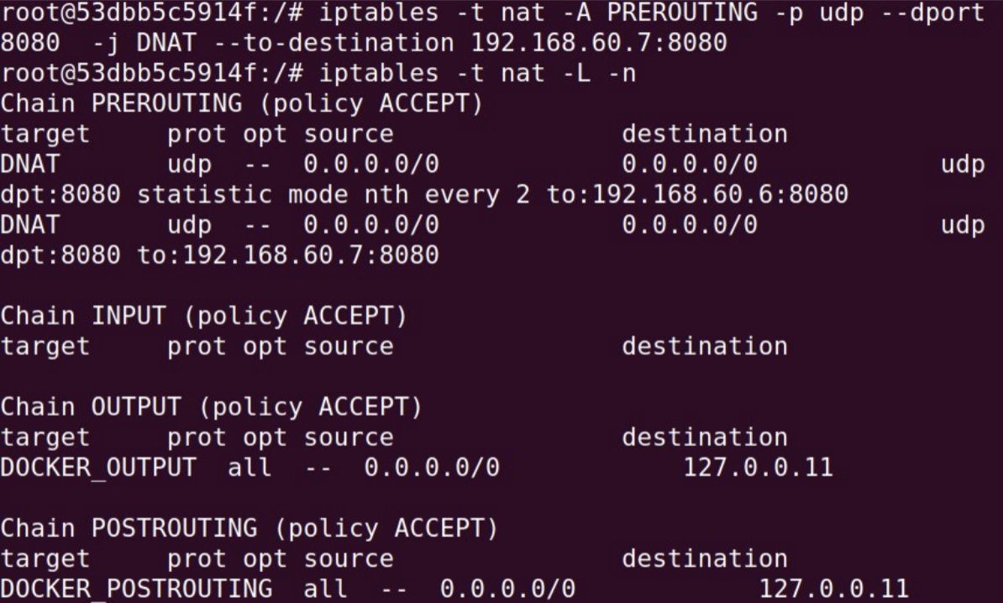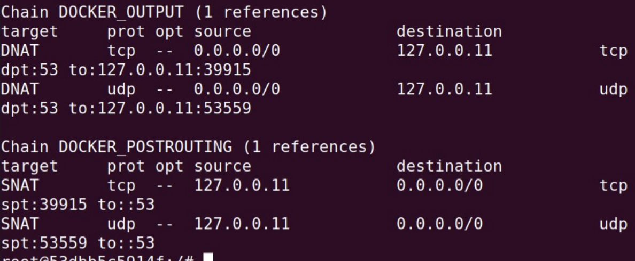Echoing packages to external servers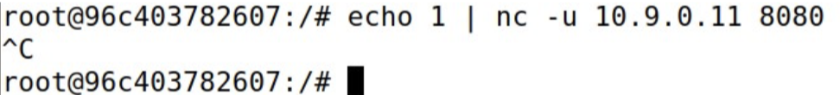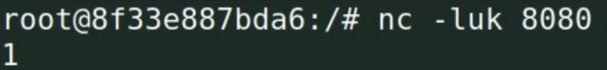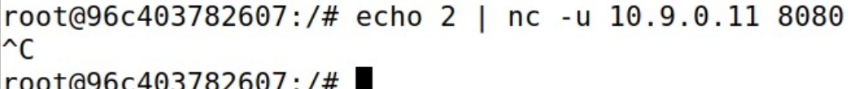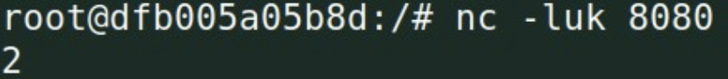192.168.60.6 takes the odd numbers, while 192.168.60.7 takes the even numbers.**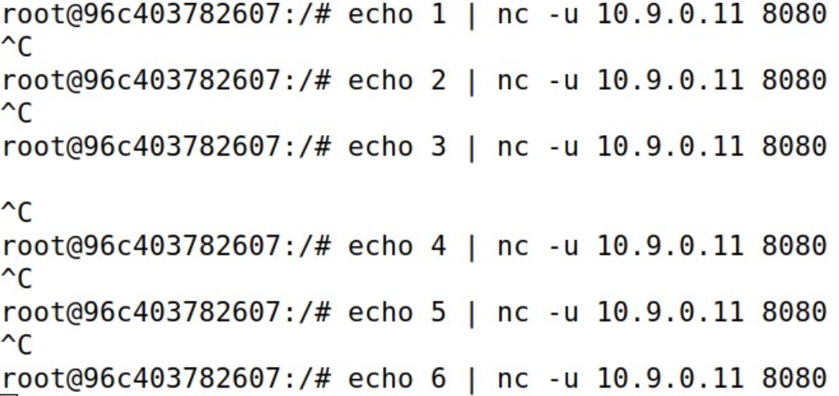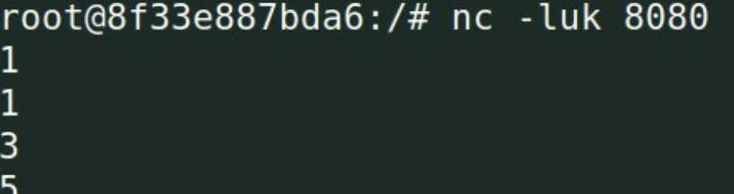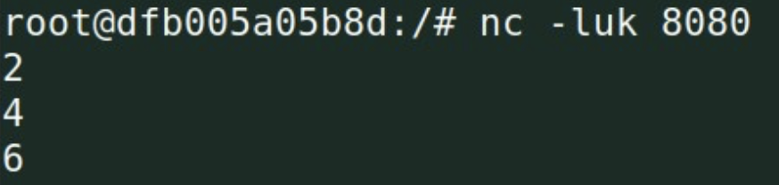

**Using random mode**